Measuring Metabolic Performance and P_{CRIT} in Atlantic cod (Gadus morhua)
Methods
Ethics
Atlantic cod were studied under ethical permit 5.8.18-07281/2025 issued to F. Jutfelt, approved by the Swedish Board of Agriculture’s ethical committee which followed the regulations set by the Animal Welfare Body at the University of Gothenburg.
Fish husbandry
Experiments on Atlantic cod (Gadus morhua) were conducted from June 17 - July 4, 2025, at the Kristineberg Marine Research Station, located on the Gullmar Fjord in Sweden. Cod were purchased directly from a commercial fisher, and were mainly caught in fyke nets. Fish were transported by car to the aquarium facilities in Kristineberg (15 min drive) and kept in flow-through tanks (2 smaller 420 l holding tanks; 2 larger 1000 l holding tanks) for a minimum of 5 days before experiments. Surface sea water (particle filtered) from the Skagerrak Bay was pumped directly to the tanks and kept at 15°C or 20°C in a temperature-controlled room. Holding tanks were supplemented with short sections of PVC tubing for shelters and plants. Fish were fed raw prawns (Pandalus borealis) to apparent satiation every 5 d. Fish were maintained on a natural summer Swedish light cycle (16 h:8 h; light:dark).
Experimental setup
An intermittent-flow respirometry system was used to measure fish oxygen uptake rate (ṀO₂) (Clark et al., 2013). The respirometry system consisted of a reservoir tray (140x81x28 cm) containing seven transparent, cylindrical respirometry chambers of different sizes and volumes (1.2 l, 3.1 l, 3.15 l, 4.1 l, 1.15 l, 3.2 l, 10 l). A flush pump (Eheim, Germany) was positioned within the reservoir tray and intermittently pumped water to each respirometer via vinyl tubing on a 10:5 min flush:seal cycle controlled by a digital timer at a rate of approximately 1.8 L min⁻¹. Excess water exited each chamber via a standpipe that extended above the water surface in the reservoir tray. A 10 mm valve was connected to each chamber so that they could be individually sealed manually. The reservoir tray, which supplied the respirometry chambers, was held at a constant 15°C or 20°C, or normoxia/hyperoxia (150% oxygen ∼ 13 mg l⁻¹) according to the fish treatment. Each respirometry chamber was equipped with an in-line recirculating pump (Eheim, 50 Hz, Germany) and an in-line optical oxygen sensor which logged data to a Firesting unit (PyroScience, Aachen, Germany). Two Firesting units recorded oxygen concentration (mg O₂ l⁻¹) and temperature of each chamber at 0.5 Hz (i.e., every 2 s) to a laptop running Oxygen Logger software (PyroScience, Germany).
Respirometry protocol
Trials were conducted on 62 fish of a range of sizes (mean ± standard error; 239.6 ± 21.8 g) acclimated to either 15°C or 20°C (>5 d), and either normoxia or hyperoxia (2 h). Fish were fasted for a minimum of 72 h before experiments. Background respiration was measured for at least 10 min, but most often >30 min, before and after each run on all chambers. To measure the maximum metabolic rate (MMR), fish were chased in a circular arena (diameter: 54 cm, height: 35 cm with approx. 12 cm water depth) for 2 minutes in sea water matching their temperature and oxygen treatment. Fish were acclimated to hyperoxia for 2 h prior to the chase. Fish were then weighed, measured and put in a chamber suitable for their size. The chambers were immediately manually sealed for 2-6 min to record their peak post-exercise metabolic demand. Once all MMR measurements were made, the automatic flush pump timer was set and all chambers were alternately flushed and sealed on a 10:5 min cycle. The chambers were covered with an opaque plastic sheet to minimize visual disturbance to the fish, and care was taken to reduce noise in the lab during experiments. Fish were held overnight in the chambers to measure their routine and standard metabolic rate (RMR and SMR, respectively). The next morning (around 9-10 am), chambers were manually sealed to measure the critical oxygen partial pressure (P_{CRIT}) of each fish. At this stage, the plastic covering was partially lifted back to expose the tails of the fish for visual monitoring. As oxygen levels declined, fish behavior was recorded until each individual rolled upside down (reached loss of equilibrium or LOE). Once a fish lost equilibrium for >3 s, we unsealed the chamber and allowed treatment-specific oxygen saturated water to flush the chamber for recovery. All fish recovered after the experiments and were eventually released to the wild.
Analysis
Data were extracted from the Firesting log files and read into Labchart for extraction of metabolic slopes in mg O₂ l⁻¹. MMR was taken as the steepest slope measured over a 2 min interval during the sealed period immediately following the chase. RMR and SMR were both calculated from slopes taken across 3 min in the middle of each 5 min sealed interval.
All respirometry measurements were paired with measurements of chamber PO₂, and tidy-formatted in Excel with individual IDs, size data, treatment data, and time stamps (see pcrit_tidydata.xlsx). This file was then read into an R script (Atlantic Cod Pcrit.R; R Core Team, 2025), where a modified version of calcSMR (Chabot et al., 2016) was used to calculate SMR for each fish as the mean of the lowest 10% of values measured after MMR was measured and before the chamber was sealed for P_{CRIT}. RMR was calculated as the mean of all slopes taken during the same interval. Slopes were adjusted for background respiration, fish mass, and chamber volume, leaving metabolic rate data in mg O₂ min⁻¹. Pcrit was then calculated for each fish using the function calc_pcrit in the respirometry package (Birk, 2025). We then used the package ggplot2 (Wickham, 2016) to plot each individual’s metabolic rate vs. chamber PO₂ (Figs. 1-4), and SMR, RMR, MMR, P_{CRIT}, and P_{LOE} vs. mass for each treatment combination (Figs. 5-9). Final calculations of SMR, RMR, MMR, P_{CRIT}, and P_{LOE} for each fish can be found paired with their treatment and size data in the pcrit_tidydata.xlsx file on the “final” tab.

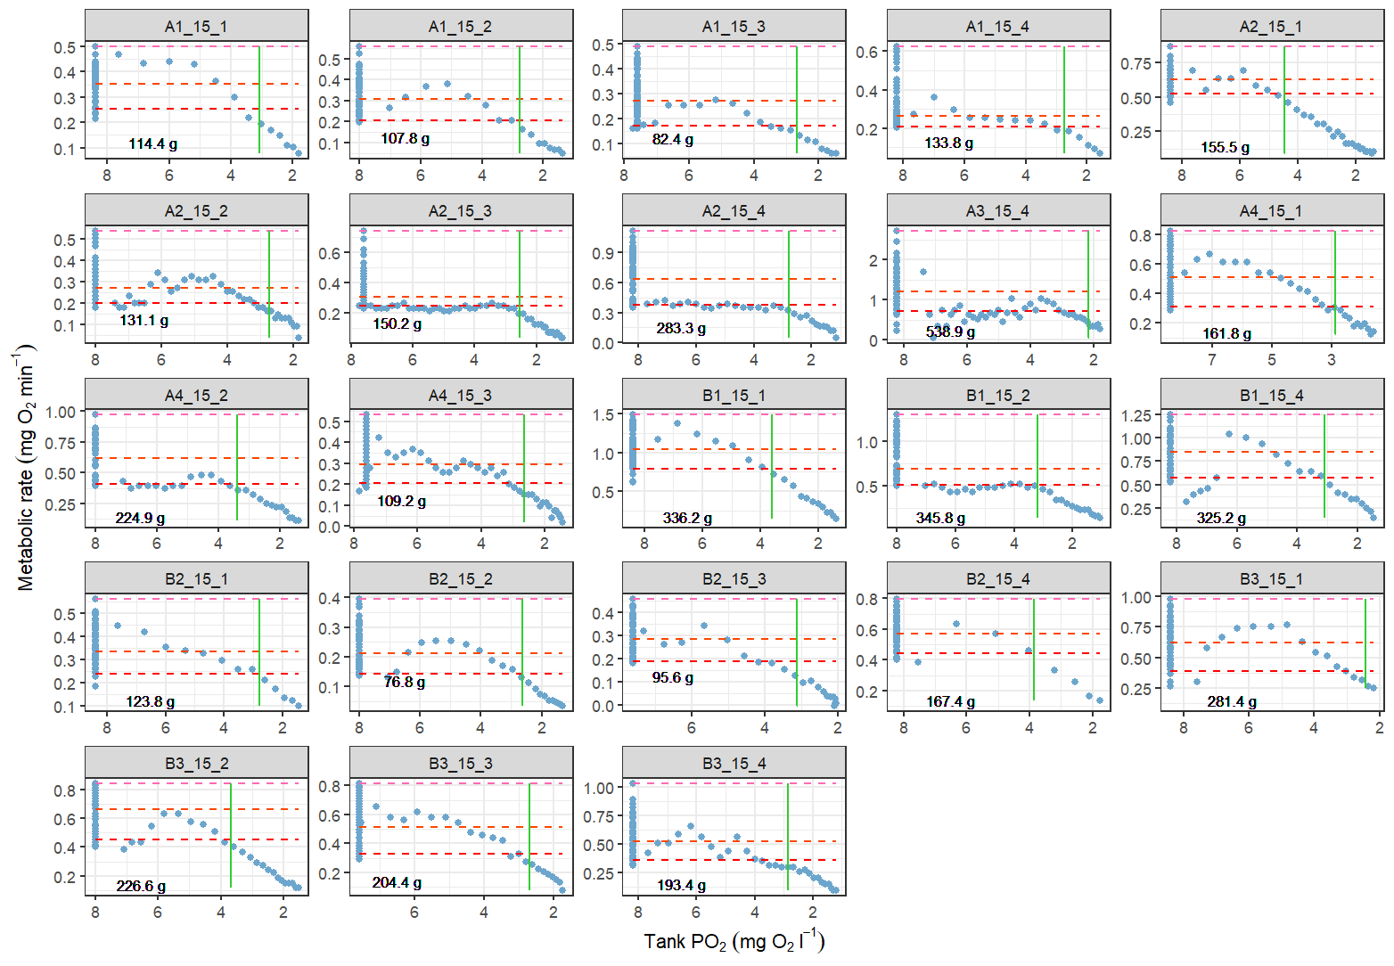
Figure 1: Individual ṀO₂ uptake measurements vs. tank PO₂ for Atlantic cod in the 15℃ and normoxia (100% air saturation) treatment. Dashed horizontal lines show SMR (red), RMR (orange), and MMR (pink). Green vertical line shows P_{CRIT} by alpha method. Fish body mass (between 76.8-538.9 g) is shown in the lower left-hand corner of each plot, and identification codes for each fish are in the header.
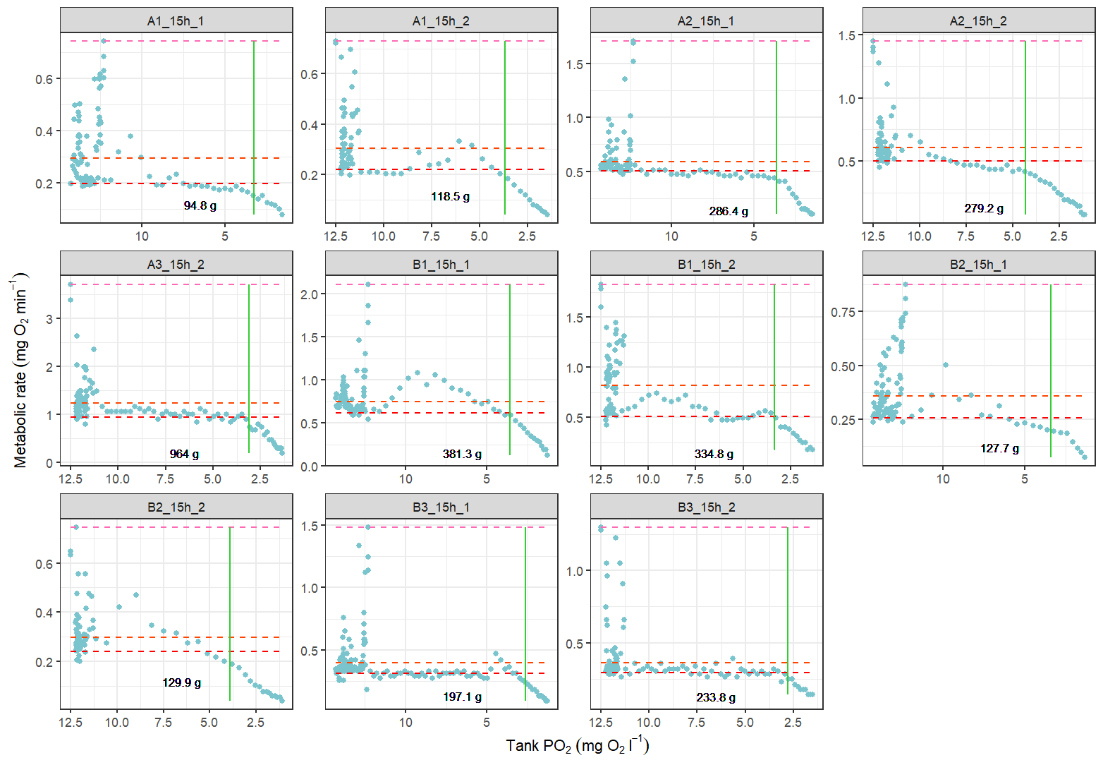
Figure 2: Individual ṀO₂ uptake measurements vs. tank PO₂ for Atlantic cod in the 15℃ and hyperoxia (150% air saturation) treatment. Dashed horizontal lines show SMR (red), RMR (orange), and MMR (pink). Green vertical line shows P_{CRIT} by alpha method. Fish body mass (between 94.8-964 g) is shown in the lower left-hand corner of each plot, and identification codes for each fish are in the header.
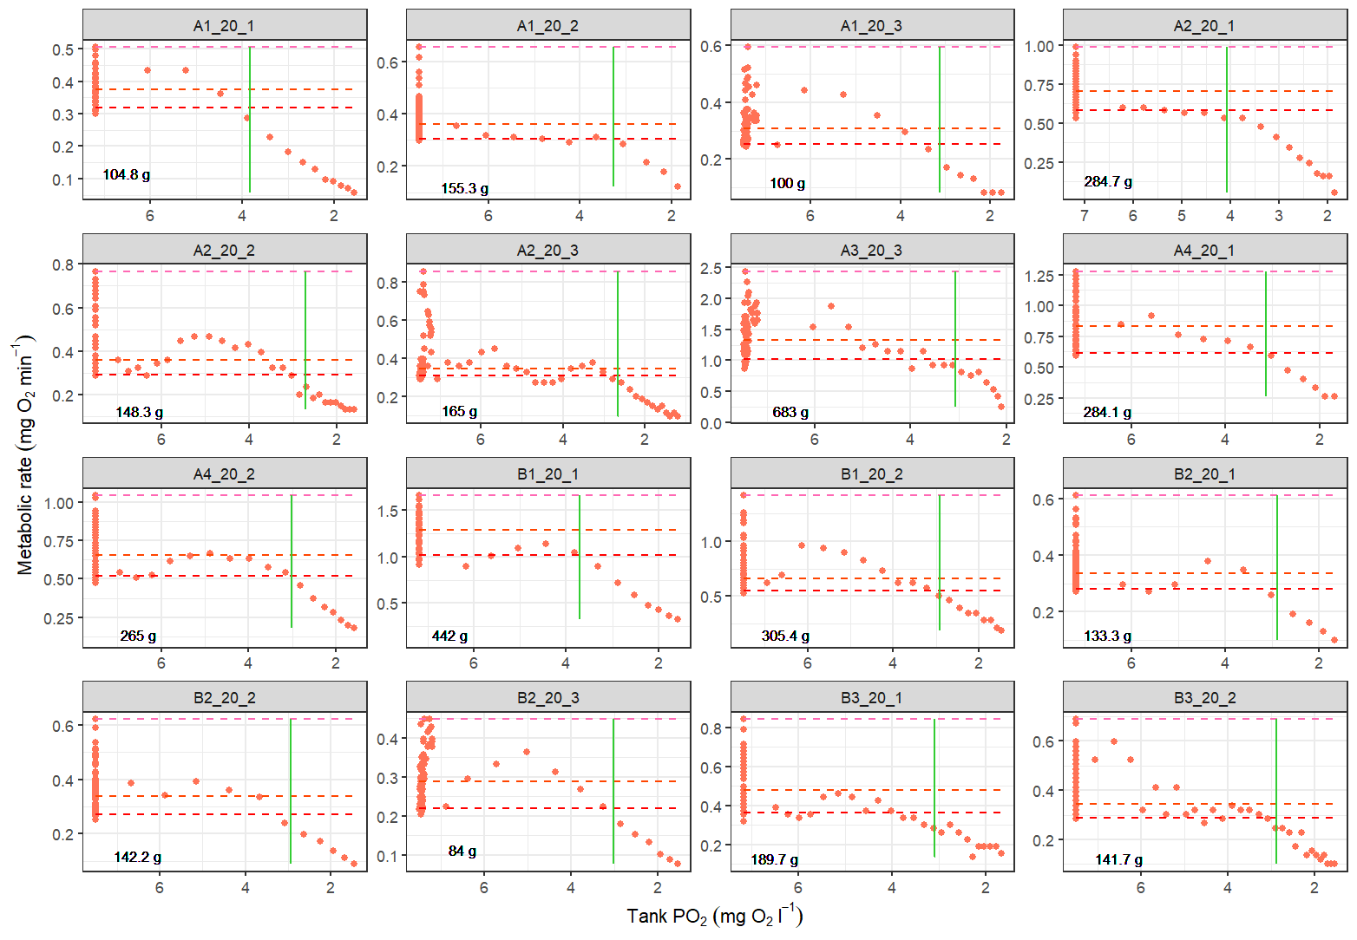
Figure 3: Individual ṀO₂ uptake measurements vs. tank PO₂ for Atlantic cod in the 20℃ and normoxia (100% air saturation) treatment. Dashed horizontal lines show SMR (red), RMR (orange), and MMR (pink). Green vertical line shows P_{CRIT} by alpha method. Fish body mass (between 84.0-683 g) is shown in the lower left-hand corner of each plot, and identification codes for each fish are in the header.
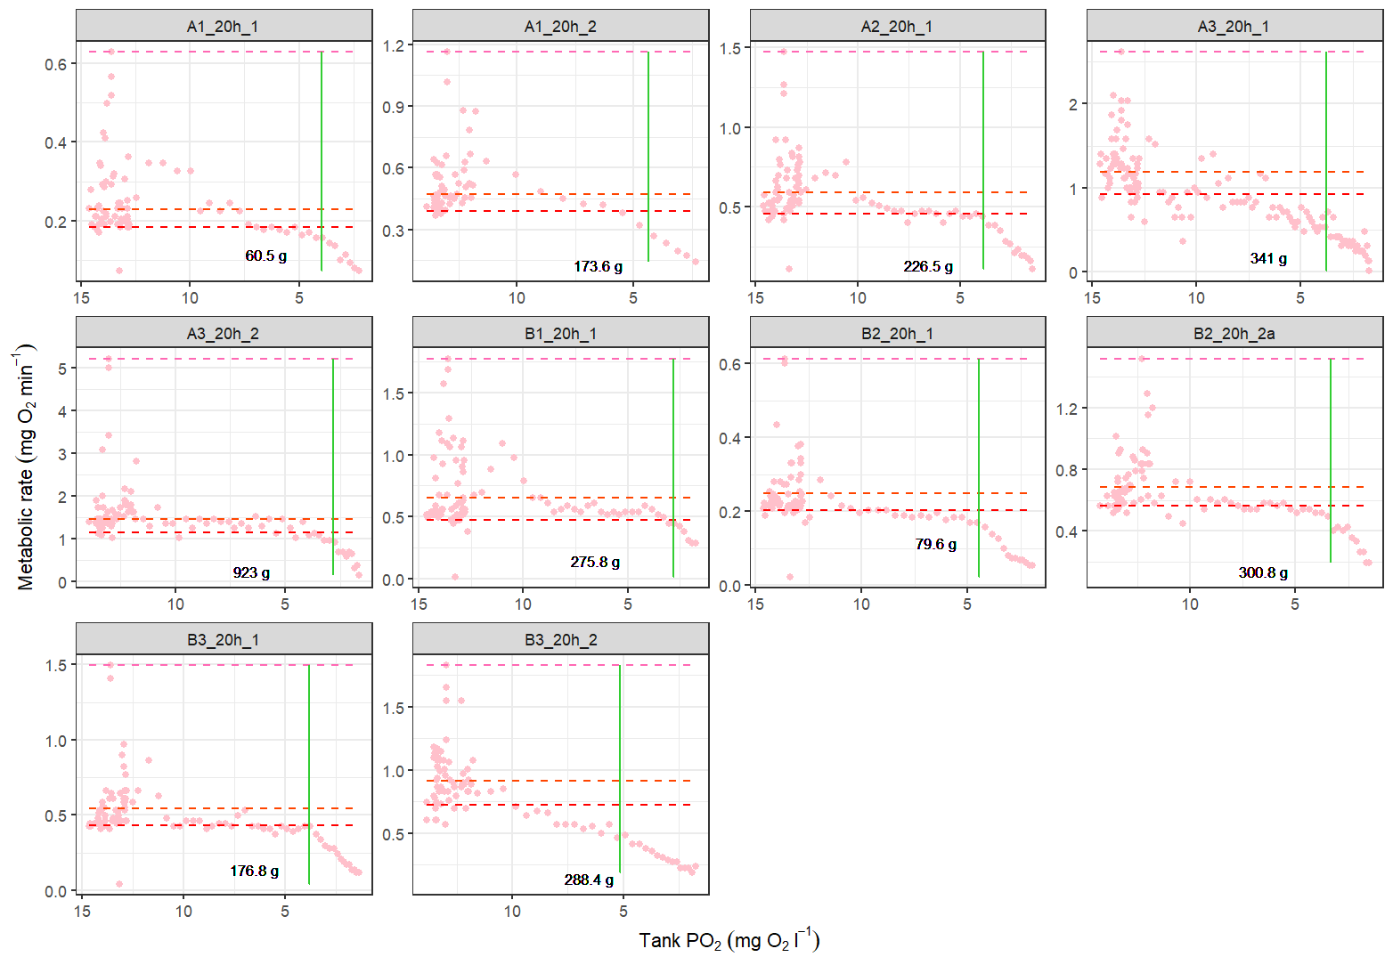
Figure 4: Individual ṀO₂ uptake measurements vs. tank PO₂ for Atlantic cod in the 20℃ and hyperoxia (150% air saturation) treatment. Dashed horizontal lines show SMR (red), RMR (orange), and MMR (pink). Green vertical line shows P_{CRIT} by alpha method. Fish body mass (between 60.5-923 g) is shown in the lower left-hand corner of each plot, and identification codes for each fish are in the header.
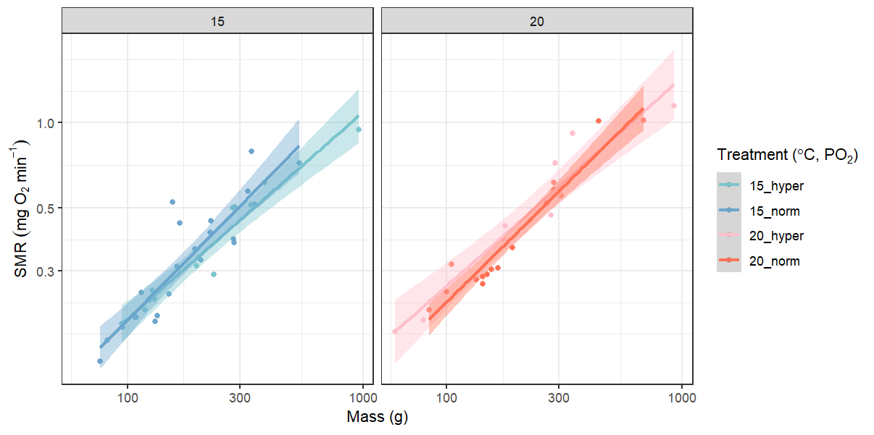
Figure 5: SMR vs. mass for Atlantic cod across each treatment, shown here on a log-log scale. Power models through these (un-logged) data have scaling exponents b_{15,normoxia} = 0.84, b_{15,hyperoxia} = 0.73, b_{20,normoxia} = 0.82, b_{20,hyperoxia} = 0.73. Hyperoxia mass-scaling of SMR tends to be shallower than normoxia, but no discernable differences were found between temperature treatments.
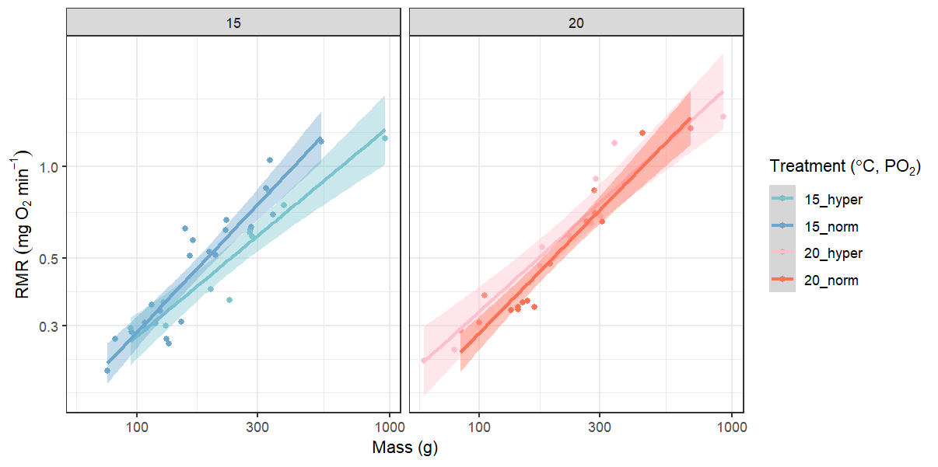
Figure 6: RMR vs. mass for Atlantic cod across each treatment, shown here on a log-log scale. Power models through these (un-logged) data have scaling exponents b_{15,normoxia} = 0.88, b_{15,hyperoxia} = 0.69, b_{20,normoxia} = 0.85, b_{20,hyperoxia} = 0.75. Hyperoxia mass-scaling of RMR was shallower than normoxia within each temperature.
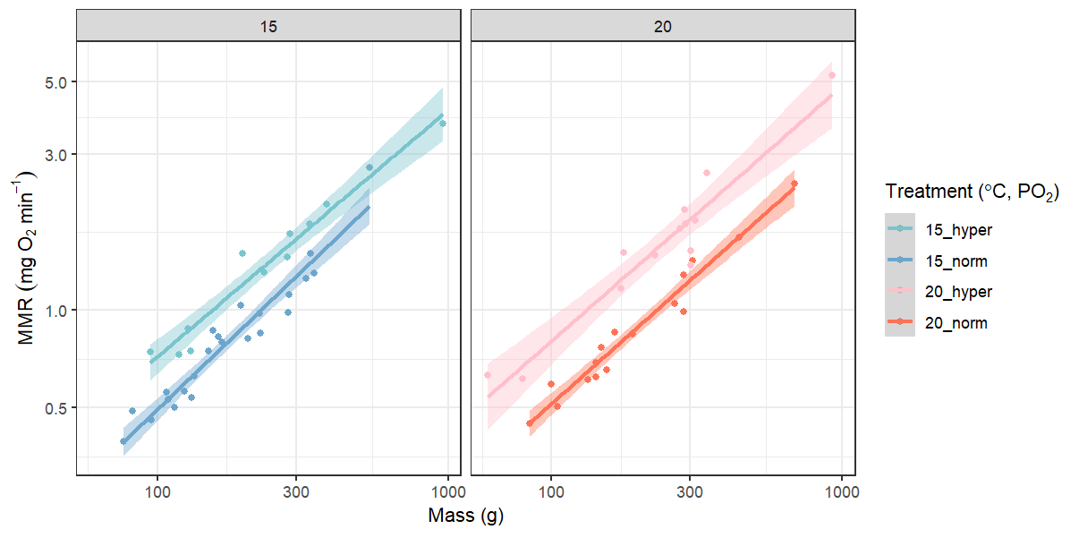
Figure 7: MMR vs. mass for Atlantic cod across each treatment, shown here on a log-log scale. Power models through these (un-logged) data have scaling exponents b_{15,normoxia} = 0.85, b_{15,hyperoxia} = 0.76, b_{20,normoxia} = 0.79, b_{20,hyperoxia} = 0.78. Hyperoxia mass-scaling of MMR was shallower than normoxia at 15℃, but not at 20℃.

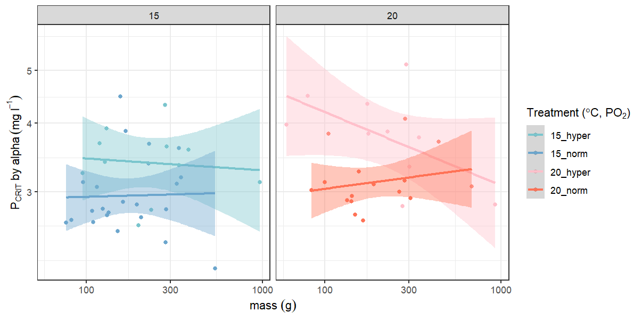
Figure 8: P_{CRIT}, expressed in mg l⁻¹ and calculated using the alpha method, vs. body mass for Atlantic cod in each of the temperature-oxygen treatment combinations. There does not appear to be a mass-effect on P_{CRIT} at 15℃ under either normoxia or hyperoxia, whereas at 20℃ there is a weakly positive trend between mass and P_{CRIT} under normoxia, and a weakly negative trend under hyperoxia.
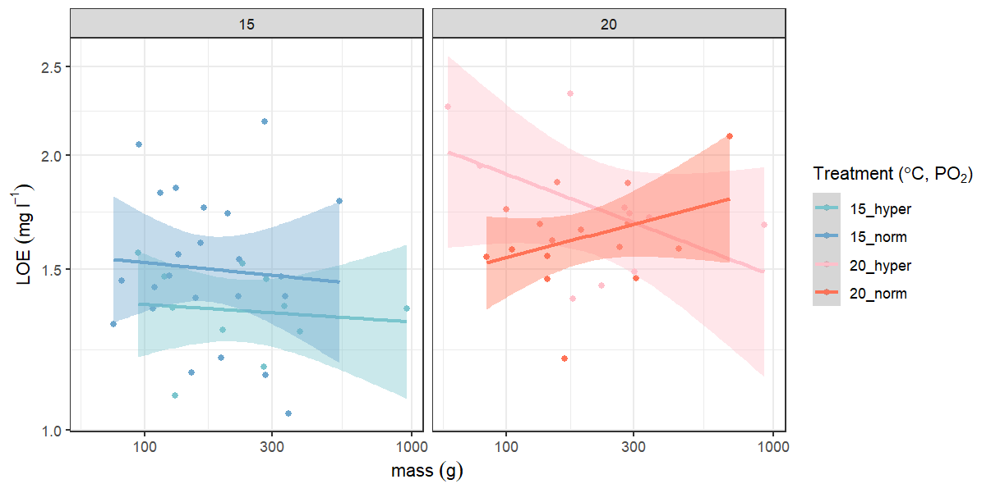
Figure 9: PO₂ (mg l⁻¹) where an individual lost equilibrium and was removed from the experimental chamber. Loss of equilibrium (LOE) is lower than P_{CRIT}, as it serves as the non-lethal endpoint for the experimental trials. There does not appear to be a mass-effect on P_{LOE} at 15℃ under either normoxia or hyperoxia, whereas at 20℃ there is a weakly positive trend between mass and P_{LOE} under normoxia, and a weakly negative trend under hyperoxia.

